Министерство образования и науки РФ

НОВОСИБИРСКИЙ ГОСУДАРСТВЕННЫЙ ТЕХНИЧЕСКИЙ УНИВЕРСИТЕТ

Кафедра теоретической и прикладной информатики

Расчетно-графическое задание

по дисциплине «Объектно-ориентированное программирование»

**Факультет:**                     ПМИ

**Группа:**                           ПМ-92

**Студенты:**                      Иванов В., Попов А., Толмачёв П.

**Преподаватель:**             Неделько В.М.

Новосибирск

2020

**1. Описание предметной области**

Реализован книжный магазин. В книжном магазине есть товар, будем рассматривать ситуацию, когда в книжном магазине продаются только книги. В любом случае, можно без проблем добавить другой класс, в котором будет реализован другой товар.

Основные классы, реализующие книжный магазин:

1) store - класс магазин, имеет атрибуты список книг (book_list), адрес (address), количество работников (amount_of_employee), количество книг (amount_books) и соответствующие им get и set операции.

2) book - товар книжного магазина, имеет атрибуты имя (name), цена (price), рейтинг (rating).

3) human - человек, самый высокий уровень абстракции, имеет атрибут имя (name), операции установить и получить имя.

3.1) client - клиент имеет операцию купить (buy), спросить совет у консультанта (ask_advice), а также оставить отзыв о книге (review).

3.2) supplier - имеет операцию привезти товар в магазин (deliver).

3.3) employee - работник магазина, имеет атрибут зарплаты (salary).

3.3.1) manager - имеет операцию проверить количество товара (провести ревизию), заказать товар (ask_supplier), проверить количество денег (get_store_money), выдать зарплату (pay_salary), выплатить налоги (pay_taxes) и атрибут количество денег (shop_money).

3.3.2) administrator - класс администратора, имеет операции управлять (management), создать бизнес-план (write_plan).

3.3.3) advisor - консультант имеет операцию проконсультировать (advice).

3.3.4) cashier - имеет операции выдать книгу (give_book), напечатать чек (print_check), взять деньги (take_money), имеет атрибут количество денег в кассе (cash_money).

3.3.5) cleaner - имеет операцию убирать (clean).

3.3.6) recruiter - работник из отдела кадров, имеет возможность уволить работника (fire) и нанять человека на работу (hire).

**2. Диаграмма классов**

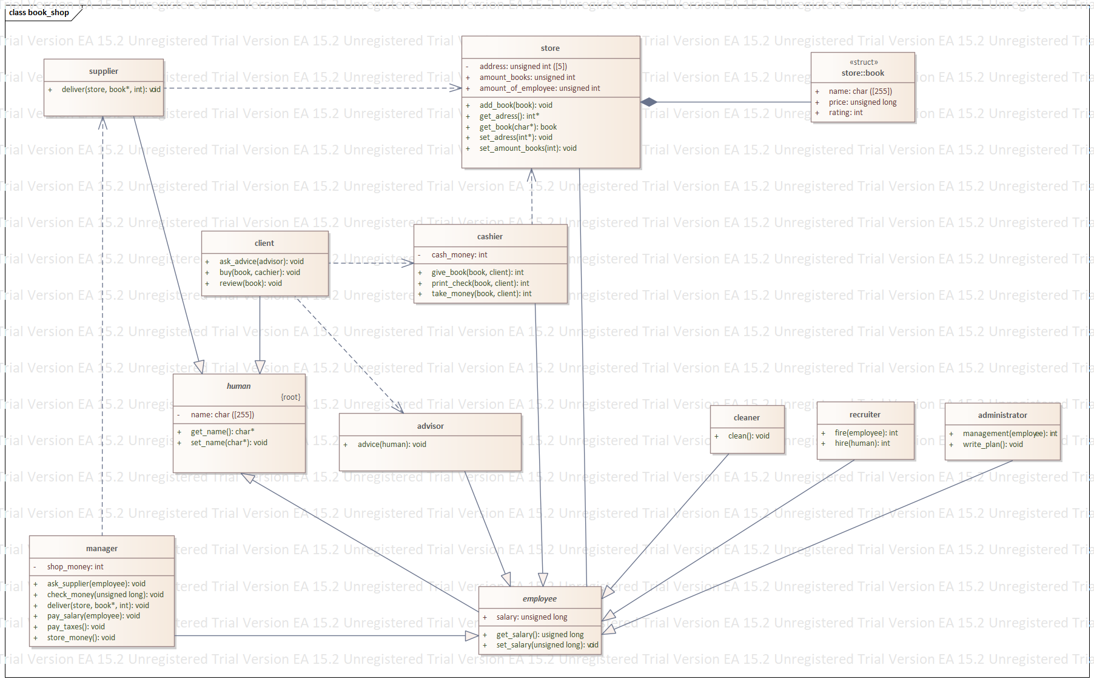

**3. Диаграмма коммуникаций**

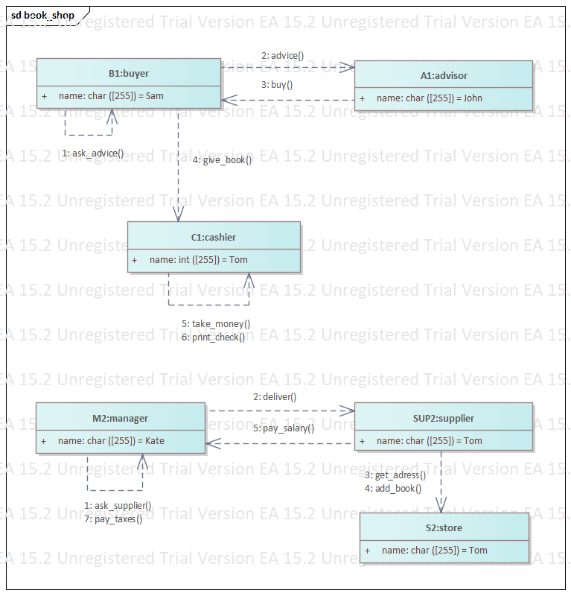

**4. Прототип кода**

*///////////////////////////////////////////////////////////*

*// supplier.h*

*// Implementation of the Class supplier*

*// Created on: 30-Dec-2020 8:39:52*

*// Original author: pm92*

*///////////////////////////////////////////////////////////*

#if !defined(EA_164800A8_E500_4898_B194_99ECCDB4FED2__INCLUDED_)

#define EA_164800A8_E500_4898_B194_99ECCDB4FED2__INCLUDED_

#include "store.h"

#include "human.h"

class supplier : public human

{

public:

supplier();

virtual ~supplier();

void deliver(store store, book* product, int amount);

};

#endif *// !defined(EA_164800A8_E500_4898_B194_99ECCDB4FED2__INCLUDED_)*

*///////////////////////////////////////////////////////////*

*// store.h*

*// Implementation of the Class store*

*// Created on: 30-äåê-2020 8:39:52*

*// Original author: pm92*

*///////////////////////////////////////////////////////////*

#if !defined(EA_71D1D215_082D_4e9a_9CF2_CE9E8A0B571E__INCLUDED_)

#define EA_71D1D215_082D_4e9a_9CF2_CE9E8A0B571E__INCLUDED_

class store

{

public:

store();

virtual ~store();

unsigned int amount_books;

unsigned int amount_of_employee;

store::book *m_book;

void add_book(book b);

int* get_adress();

book get_book(char* name);

void set_adress(int* adress);

void set_amount_books(int size);

private:

struct book

{

public:

char name[255];

unsigned long price;

int rating;

};

unsigned int address[5];

};

#endif *// !defined(EA_BB2AE888_AAFB_42c8_B882_A8907FE8AC0E__INCLUDED_)*

*///////////////////////////////////////////////////////////*

*// recruiter.h*

*// Implementation of the Class recruiter*

*// Created on: 30-äåê-2020 8:39:52*

*// Original author: pm92*

*///////////////////////////////////////////////////////////*

#if !defined(EA_D80DECC6_F2C3_433a_9372_41E3392D4710__INCLUDED_)

#define EA_D80DECC6_F2C3_433a_9372_41E3392D4710__INCLUDED_

#include "employee.h"

#include "human.h"

class recruiter : public employee

{

public:

recruiter();

virtual ~recruiter();

int fire(employee worker);

int hire(human human);

};

#endif *// !defined(EA_D80DECC6_F2C3_433a_9372_41E3392D4710__INCLUDED_)*

*///////////////////////////////////////////////////////////*

*// manager.h*

*// Implementation of the Class manager*

*// Created on: 30-äåê-2020 8:39:52*

*// Original author: pm92*

*///////////////////////////////////////////////////////////*

#if !defined(EA_BFC1DCFF_9001_469c_928D_64AC3E87F390__INCLUDED_)

#define EA_BFC1DCFF_9001_469c_928D_64AC3E87F390__INCLUDED_

#include "employee.h"

#include "store.h"

#include "supplier.h"

class manager : public employee

{

public:

manager();

virtual ~manager();

void ask_supplier(employee worker);

void check_money(unsigned long money);

void deliver(store store, book* product, int amount);

void pay_salary(employee pay);

void pay_taxes();

void store_money();

private:

int shop_money;

};

#endif *// !defined(EA_BFC1DCFF_9001_469c_928D_64AC3E87F390__INCLUDED_)*

*///////////////////////////////////////////////////////////*

*// human.h*

*// Implementation of the Class human*

*// Created on: 30-äåê-2020 8:39:52*

*// Original author: pm92*

*///////////////////////////////////////////////////////////*

#if !defined(EA_E515F8D0_9F4C_45d2_B846_CECA1E3B0586__INCLUDED_)

#define EA_E515F8D0_9F4C_45d2_B846_CECA1E3B0586__INCLUDED_

class human

{

public:

human();

virtual ~human();

char* get_name();

void set_name(char* name);

private:

char name[255];

};

#endif *// !defined(EA_E515F8D0_9F4C_45d2_B846_CECA1E3B0586__INCLUDED_)*

*///////////////////////////////////////////////////////////*

*// employee.h*

*// Implementation of the Class employee*

*// Created on: 30-äåê-2020 8:39:52*

*// Original author: pm92*

*///////////////////////////////////////////////////////////*

#if !defined(EA_5CD145F0_D498_4da5_AB45_B0069DC099B9__INCLUDED_)

#define EA_5CD145F0_D498_4da5_AB45_B0069DC099B9__INCLUDED_

#include "human.h"

#include "store.h"

class employee : public human

{

public:

employee();

virtual ~employee();

unsigned long salary;

store *m_store;

usigned long get_salary();

void set_salary(unsigned long sal);

};

#endif *// !defined(EA_5CD145F0_D498_4da5_AB45_B0069DC099B9__INCLUDED_)*

*///////////////////////////////////////////////////////////*

*// client.h*

*// Implementation of the Class client*

*// Created on: 30-äåê-2020 8:39:52*

*// Original author: pm92*

*///////////////////////////////////////////////////////////*

#if !defined(EA_BB2E4376_ED55_4ec9_9A38_B56C2E4DC13C__INCLUDED_)

#define EA_BB2E4376_ED55_4ec9_9A38_B56C2E4DC13C__INCLUDED_

#include "advisor.h"

#include "store.h"

#include "cashier.h"

#include "human.h"

class client : public human

{

public:

client();

virtual ~client();

void ask_advice(advisor advisor);

void buy(book product, cachier c);

void review(store::book product);

};

#endif *// !defined(EA_BB2E4376_ED55_4ec9_9A38_B56C2E4DC13C__INCLUDED_)*

*///////////////////////////////////////////////////////////*

*// cleaner.h*

*// Implementation of the Class cleaner*

*// Created on: 30-äåê-2020 8:39:52*

*// Original author: pm92*

*///////////////////////////////////////////////////////////*

#if !defined(EA_F3944AAC_36A7_4246_90D4_BD92A00A977D__INCLUDED_)

#define EA_F3944AAC_36A7_4246_90D4_BD92A00A977D__INCLUDED_

#include "employee.h"

class cleaner : public employee

{

public:

cleaner();

virtual ~cleaner();

void clean();

};

#endif *// !defined(EA_F3944AAC_36A7_4246_90D4_BD92A00A977D__INCLUDED_)*

*///////////////////////////////////////////////////////////*

*// cashier.h*

*// Implementation of the Class cashier*

*// Created on: 30-äåê-2020 8:39:52*

*// Original author: pm92*

*///////////////////////////////////////////////////////////*

#if !defined(EA_78D72BE3_CFD6_43e4_BB10_13BA0997A731__INCLUDED_)

#define EA_78D72BE3_CFD6_43e4_BB10_13BA0997A731__INCLUDED_

#include "client.h"

#include "store.h"

#include "employee.h"

class cashier : public employee

{

public:

cashier();

virtual ~cashier();

int give_book(store::book product, client buyer);

int print_check(store::book product, client buyer);

int take_money(store::book product, client buyer);

private:

int cash_money;

};

#endif *// !defined(EA_78D72BE3_CFD6_43e4_BB10_13BA0997A731__INCLUDED_)*

*///////////////////////////////////////////////////////////*

*// book.h*

*// Implementation of the Class book*

*// Created on: 30-äåê-2020 8:06:42*

*// Original author: pm92*

*///////////////////////////////////////////////////////////*

#if !defined(EA_4F21377E_CBE7_43af_BDAE_0DC748FC1A61__INCLUDED_)

#define EA_4F21377E_CBE7_43af_BDAE_0DC748FC1A61__INCLUDED_

struct book

{

public:

char name[255];

unsigned long price;

int rating;

};

#endif *// !defined(EA_4F21377E_CBE7_43af_BDAE_0DC748FC1A61__INCLUDED_)*

*///////////////////////////////////////////////////////////*

*// advisor.h*

*// Implementation of the Class advisor*

*// Created on: 30-äåê-2020 8:39:52*

*// Original author: pm92*

*///////////////////////////////////////////////////////////*

#if !defined(EA_CD3F5DFC_C2A2_4f01_BAA9_CE5C2A75D4E9__INCLUDED_)

#define EA_CD3F5DFC_C2A2_4f01_BAA9_CE5C2A75D4E9__INCLUDED_

#include "human.h"

#include "employee.h"

class advisor : public employee

{

public:

advisor();

virtual ~advisor();

void advice(human human);

};

#endif *// !defined(EA_CD3F5DFC_C2A2_4f01_BAA9_CE5C2A75D4E9__INCLUDED_)*

*///////////////////////////////////////////////////////////*

*// administrator.h*

*// Implementation of the Class administrator*

*// Created on: 30-äåê-2020 8:39:51*

*// Original author: pm92*

*///////////////////////////////////////////////////////////*

#if !defined(EA_83DF3F64_0620_406b_BD49_7FC167BD3C50__INCLUDED_)

#define EA_83DF3F64_0620_406b_BD49_7FC167BD3C50__INCLUDED_

#include "employee.h"

class administrator : public employee

{

public:

administrator();

virtual ~administrator();

int management(employee employee);

void write_plan();

};

#endif *// !defined(EA_83DF3F64_0620_406b_BD49_7FC167BD3C50__INCLUDED_)*

*///////////////////////////////////////////////////////////*

*// supplier.cpp*

*// Implementation of the Class supplier*

*// Created on: 30-äåê-2020 8:39:52*

*// Original author: pm92*

*///////////////////////////////////////////////////////////*

#include "supplier.h"

supplier::supplier(){

}

supplier::~supplier(){

}

void supplier::deliver(store store, book* product, int amount){

}

*///////////////////////////////////////////////////////////*

*// store.cpp*

*// Implementation of the Class store*

*// Created on: 30-äåê-2020 8:39:52*

*// Original author: pm92*

*///////////////////////////////////////////////////////////*

#include "store.h"

store::store(){

}

store::~store(){

}

void store::add_book(book b){

}

int* store::get_adress(){

return NULL;

}

book store::get_book(char* name){

return NULL;

}

void store::set_adress(int* adress){

}

void store::set_amount_books(int size){

}

*///////////////////////////////////////////////////////////*

*// recruiter.cpp*

*// Implementation of the Class recruiter*

*// Created on: 30-äåê-2020 8:39:52*

*// Original author: pm92*

*///////////////////////////////////////////////////////////*

#include "recruiter.h"

recruiter::recruiter(){

}

recruiter::~recruiter(){

}

int recruiter::fire(employee worker){

return 0;

}

int recruiter::hire(human human){

return 0;

}

*///////////////////////////////////////////////////////////*

*// manager.cpp*

*// Implementation of the Class manager*

*// Created on: 30-äåê-2020 8:39:52*

*// Original author: pm92*

*///////////////////////////////////////////////////////////*

#include "manager.h"

manager::manager(){

}

manager::~manager(){

}

void manager::ask_supplier(employee worker){

}

void manager::check_money(unsigned long money){

}

void manager::deliver(store store, book* product, int amount){

}

void manager::pay_salary(employee pay){

}

void manager::pay_taxes(){

}

void manager::store_money(){

}

*///////////////////////////////////////////////////////////*

*// human.cpp*

*// Implementation of the Class human*

*// Created on: 30-äåê-2020 8:39:52*

*// Original author: pm92*

*///////////////////////////////////////////////////////////*

#include "human.h"

human::human(){

}

human::~human(){

}

char* human::get_name(){

return NULL;

}

void human::set_name(char* name){

}

*///////////////////////////////////////////////////////////*

*// employee.cpp*

*// Implementation of the Class employee*

*// Created on: 30-äåê-2020 8:39:52*

*// Original author: pm92*

*///////////////////////////////////////////////////////////*

#include "employee.h"

employee::employee(){

}

employee::~employee(){

}

usigned long employee::get_salary(){

return NULL;

}

void employee::set_salary(unsigned long sal){

}

*///////////////////////////////////////////////////////////*

*// client.cpp*

*// Implementation of the Class client*

*// Created on: 30-äåê-2020 8:39:52*

*// Original author: pm92*

*///////////////////////////////////////////////////////////*

#include "client.h"

client::client(){

}

client::~client(){

}

void client::ask_advice(advisor advisor){

}

void client::buy(book product, cachier c){

}

void client::review(store::book product){

}

*///////////////////////////////////////////////////////////*

*// cleaner.cpp*

*// Implementation of the Class cleaner*

*// Created on: 30-äåê-2020 8:39:52*

*// Original author: pm92*

*///////////////////////////////////////////////////////////*

#include "cleaner.h"

cleaner::cleaner(){

}

cleaner::~cleaner(){

}

void cleaner::clean(){

}

*///////////////////////////////////////////////////////////*

*// cashier.cpp*

*// Implementation of the Class cashier*

*// Created on: 30-äåê-2020 8:39:52*

*// Original author: pm92*

*///////////////////////////////////////////////////////////*

#include "cashier.h"

cashier::cashier(){

}

cashier::~cashier(){

}

int cashier::give_book(store::book product, client buyer){

return 0;

}

int cashier::print_check(store::book product, client buyer){

return 0;

}

int cashier::take_money(store::book product, client buyer){

return 0;

}

*///////////////////////////////////////////////////////////*

*// book.cpp*

*// Implementation of the Class book*

*// Created on: 30-äåê-2020 8:06:42*

*// Original author: pm92*

*///////////////////////////////////////////////////////////*

#include "book.h"

*///////////////////////////////////////////////////////////*

*// advisor.cpp*

*// Implementation of the Class advisor*

*// Created on: 30-äåê-2020 8:39:52*

*// Original author: pm92*

*///////////////////////////////////////////////////////////*

#include "advisor.h"

advisor::advisor(){

}

advisor::~advisor(){

}

void advisor::advice(human human){

}

*///////////////////////////////////////////////////////////*

*// administrator.cpp*

*// Implementation of the Class administrator*

*// Created on: 30-äåê-2020 8:39:52*

*// Original author: pm92*

*///////////////////////////////////////////////////////////*

#include "administrator.h"

administrator::administrator(){

}

administrator::~administrator(){

}

int administrator::management(employee employee){

return 0;

}

void administrator::write_plan(){

}